**Training (Site A – 2019)**

**Dataset:**

**Total Data** -> X: (2235904, 28, 6), Y: (2235904,)

**Subset Data**: 25% of total data -> X: (558976, 28, 6), Y: (558976, )

**Train Data:** 80% of subset data -> X: (447180, 28, 6), Y: (447180,)

**Val Data:** 20% of subset data -> X: (111796, 28, 6), Y: (111796,)

**BCNN**

**Model Architecture:**

Batch Avg

Input -> Conv Norm -> Pool -> num -> Output



1d 1d 1d classes



**Feature Extractor** **Classifier**

**Layers:** Bayesian Linear, Bayesian Conv1d

**Activation:** ReLu

**Loss:** ELBO -> CE (Class Weights) + KL Divergence (Regularization term)

**Optimizer:** Adam

**Hyper-Parameters:**

BATCH_SIZE = 64

NUM_CLASSES = 3

INPUT_DIM = 6

OUTPUT_DIM = NUM_CLASSES

KL_WEIGHT = 1e-9

LR = 1e-3

EPOCHS = 10

T = 10

PRIORS = {

'prior_mu': 0.0,

'prior_sigma': 0.1,

'posterior_mu_initial': (0.0, 0.1),

'posterior_rho_initial': (-3.0, 0.1)

} (Gaussian Prior)

**Results:**

Train Acc: 95.39%

Val Acc: 95.22%

Kappa: 0.9204

Per Class F1: [0.900, 0.969, 0.954]

Macro (Avg) F1: 0.9411

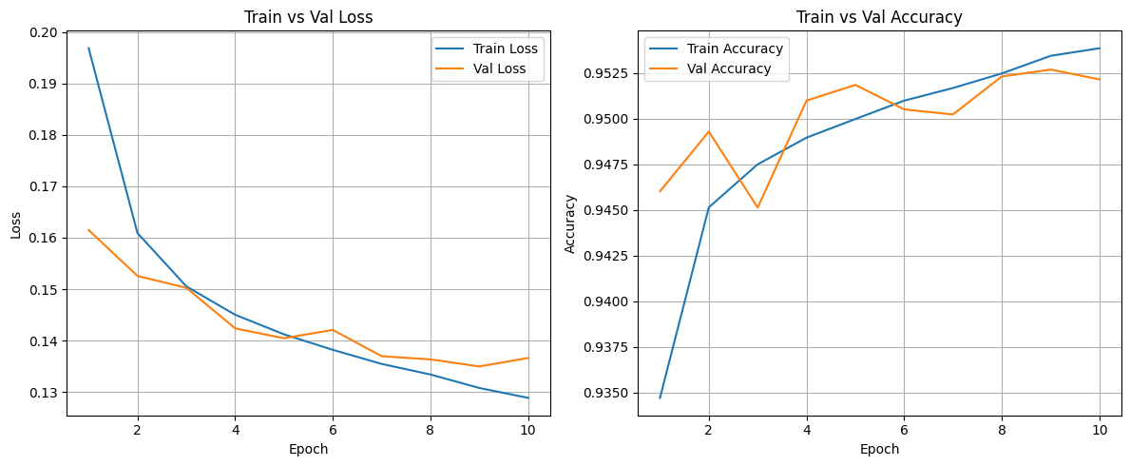

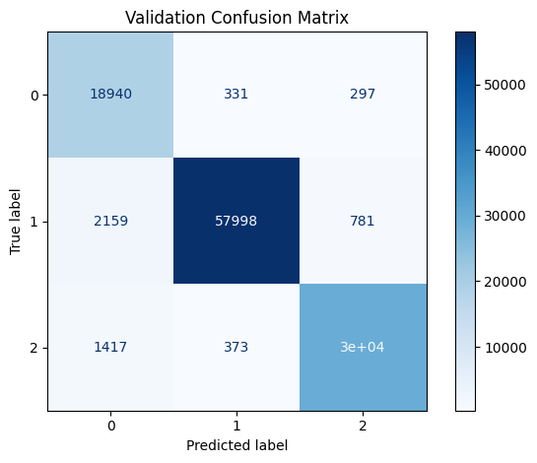

**Testing Without Adaptation**

|  |  |  |
| --- | --- | --- |
| **Experiment** | **BCNN** | **Deterministic CNN** |
| A2019 -> A2019 | **Acc**=95.2%, **kappa**=92.05%, **AvgF1**=94.12%,  **Per-class F1**: [0.900, 0.969, 0.953] | **Acc**=95.2%, **Kappa**=92.01%, **AvgF1**=94.11%,  **Per-class F1**:[0.901, 0.969, 0.954] |
| A2019 -> A2020 | **Acc**=91.63%, **kappa**=85.85%, **AvgF1**=90.36%,  **Per-class F1**: [0.880, 0.942, 0.888] | **Acc**=93.2%, **Kappa**=88.39%, **AvgF1**=91.78%, **Per-class F1**: [0.881, 0.955, 0.917] |
| A2019 -> A2021 | **Acc**=90.7%, **kappa**=84.86%, **AvgF1**=90.21%,  **Per-class F1**: [0.899, 0.925, 0.881] | **Acc**=92.2%, **Kappa**=87.15%, **AvgF1**=91.71%, **Per-class** **F1**: [0.914, 0.937, 0.901] |
| A2019 -> B2019 | **Acc**=52.8%, **kappa**=20.18%, **AvgF1**=49.15%,  **Per-class F1**: [0.548, 0.375, 0.551] | **Acc**=59.4%, **Kappa**=34.42%, **AvgF1**=61.14%, **Per-class F1**:[0.578, 0.676, 0.580] |
| A2019 -> B2020 | **Acc**=55.18%, **kappa**=25.19%, **AvgF1**=50.31%,  **Per-class F1**: [0.506, 0.350, 0.653] | **Acc=60.0%, Kappa=35.18%, AvgF1=59.87%, Per-class F1**: [0.509, 0.612, 0.675] |
| A2019 -> B2021 | **Acc**=52.84%, **kappa**=23.98%, **AvgF1**=48.49%,  **Per-class F1**: [0.473, 0.330, 0.652] | **Acc**=60.8%, **Kappa**=38.97%, **AvgF1**=61.01%, **Per-class F1**: [0.504, 0.651, 0.676] |
| A2019 -> C2019 | **Acc**=68.26%, **kappa**=32.15%, **AvgF1**=46.27%,  **Per-class F1**: [0.774, 0.006, 0.607] | **Acc**=68.8%, **Kappa**=37.94%, **AvgF1**=54.35%, **Per-class F1**: [0.769, 0.233, 0.629] |
| A2019 -> C2020 | **Acc**=62.17%, **kappa**=29.87%, **AvgF1**=47.32%,  **Per-class F1**: [0.715, 0.137, 0.567] | **Acc**=68.97%, **Kappa**=45.49%, **AvgF1**=60.85%, **Per-class F1**: [0.762, 0.402, 0.662] |
| A2019 -> C2021 | **Acc**=47.38%, **kappa**=14.02%, **AvgF1**=34.99%,  **Per-class F1**: [0.608, 0.108, 0.333] | **Acc**=55.1%, **Kappa**=27.24%, **AvgF1**=46.15%, **Per-class F1**: [0.658, 0.217, 0.510] |

**A2019 -> A2019**

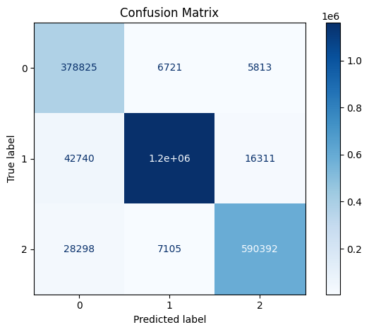

**A2019 -> A2020**

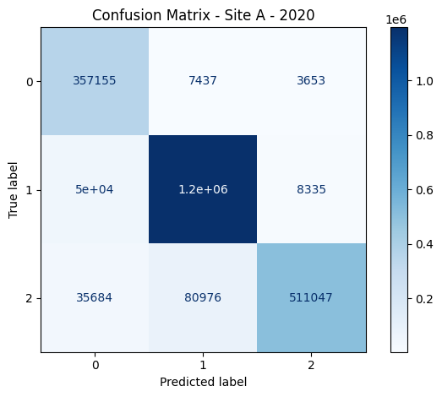

**A2019 -> A2021**

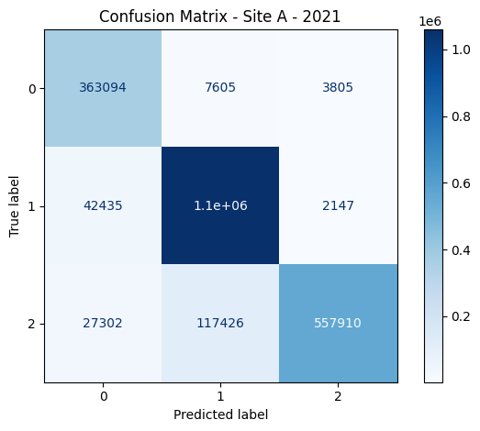

**A2019 -> B2019**

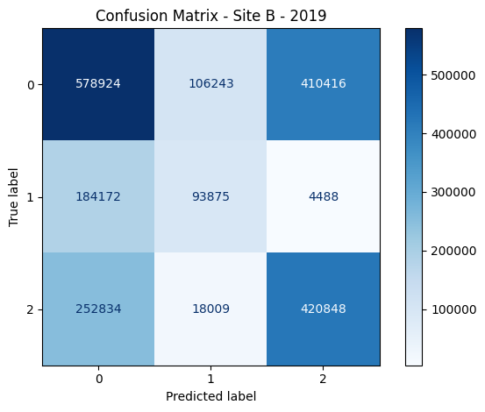

**A2019 -> B2020**

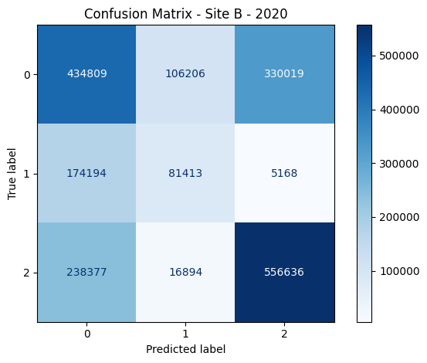

**A2019 -> B2021**

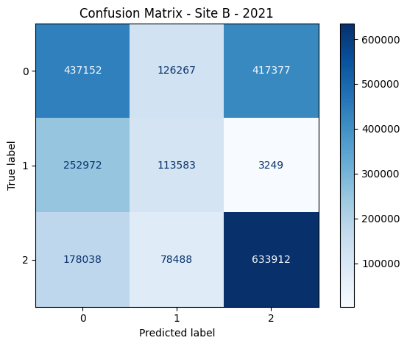

**A2019 -> C2019**

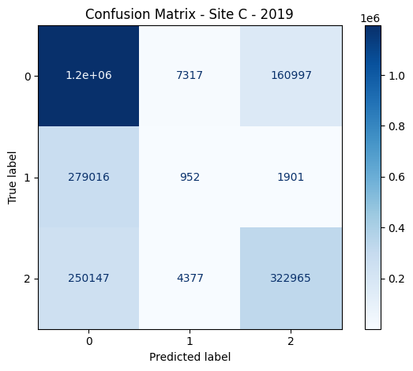

**A2019 -> C2020**

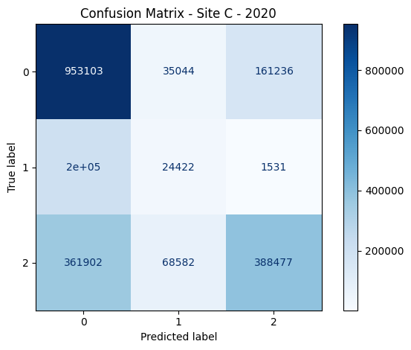

**A2019 -> C2021**

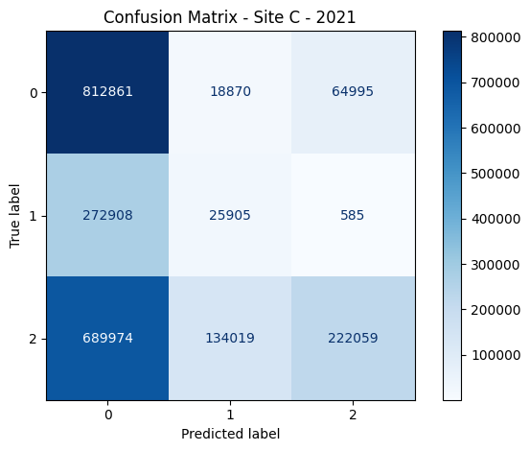

**Evaluation in Deterministic Way**

